**Institute of Engineering & Management**

**Department of Computer Science & Engineering**

**Software Tools Laboratory for 2nd year 4th Semester 2018**

**Code: CS 492**

**Date:** 21/03/2018

**Week-6**

**Assignment-1**

**Problem Statement:** Create a traffic signalling system using timer in VB6.

**Screen-Shot:**

**Form-1:**

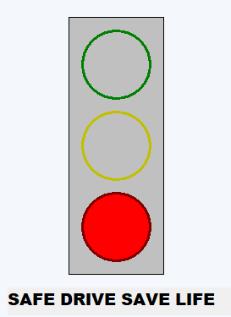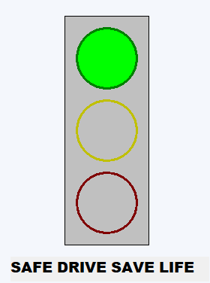

**Pic1:** The Signal is Green **Pic2:** The Signal is Red

**Form Code:**

**For Form-1:**

Dim count1 As Integer  
  
Private Sub Form_Load()  
Timer1.Enabled = True  
End Sub  
  
Private Sub Timer1_Timer()  
If count1 > 36 Then  
count1 = 0  
End If  
count1 = count1 + 1  
If count1 <= 16 Then  
Shape2.FillStyle = 0  
Shape2.FillColor = vbGreen  
Shape3.FillStyle = 1  
Shape4.FillStyle = 1  
ElseIf count1 > 16 And count1 <= 22 Then  
Shape3.FillStyle = 0  
Shape3.FillColor = vbYellow  
Shape2.FillStyle = 1  
Shape4.FillStyle = 1  
ElseIf count1 > 22 And count1 <= 32 Then  
Shape4.FillStyle = 0  
Shape4.FillColor = vbRed  
Shape3.FillStyle = 1  
Shape2.FillStyle = 1  
ElseIf count1 > 32 And count1 <= 36 Then  
Shape3.FillStyle = 1  
Shape2.FillStyle = 1  
Shape4.FillColor = vbRed  
If count1 = 33 Then  
Shape4.FillStyle = 1  
ElseIf count1 = 34 Then  
Shape4.FillStyle = 0  
ElseIf count1 = 35 Then  
Shape4.FillStyle = 1  
ElseIf count1 = 36 Then  
Shape4.FillStyle = 0  
End If  
End If  
End Sub

**Assignment-2**

**Problem Statement:** Load an image file in your VB form by clicking a “Load Image” button and  
show the name of the image file just below the loaded image. Create two more buttons in your form - “Change Colour” and “Change Font” which will be used to change the colour and font style of the image name. Use common dialog box to implement all these functionalities.

**Screen-Shot:**

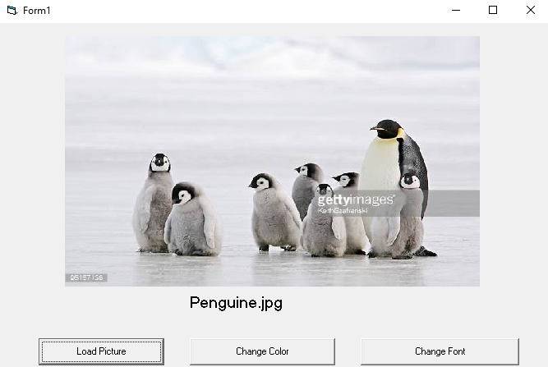

**Pic1:** After loading the picture

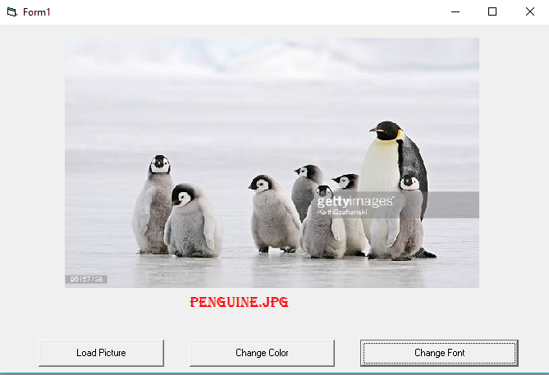

**Pic2:** After changing the colour & the font of the picture’s name

**Form Code:**

**For Form-1:**

Private Sub Command1_Click()

Cd1.Filter = "Image Files | *.jpg;*.jpeg;*.bmp;*.png;*.png"

Cd1.ShowOpen

Image1.Picture = LoadPicture(Cd1.FileName)

Label1.Caption = Cd1.FileTitle

End Sub

Private Sub Command2_Click()

Cd1.ShowColor

Label1.ForeColor = Cd1.Color

End Sub

Private Sub Command3_Click()

Cd1.ShowFont

Label1.FontName = Cd1.FontName

End Sub

**Assignment-3**

**Problem Statement:** Create a VB menu. The menu will contain two main menus: - FILE AND HELP.   
Under the FILE menu these will be situated: - NEW, OPEN, SAVE, SAVE AS, PRINT, EXIT. Under the HELP menu there will be a sub menu named as ABOUT US. Every option must have a short cut key with a suitable letter. Every submenu must be clickable. When you click the NEW, a new form will be created with a label: - “THIS IS NEW FORM”. When you click OPEN, a dialog box will be opened and select an image file from that dialog box and display that image in a picture box on your default form. When you will click the SAVE & SAVE AS, suitable message box will be opened. When you will click the PRINT option, you will be able to change the background colour of a form with a system palette. After clicking EXIT, the application will be closed. After clicking on ABOUT US a message box will be displayed with your details in a new line.

**Screen-Shot:**

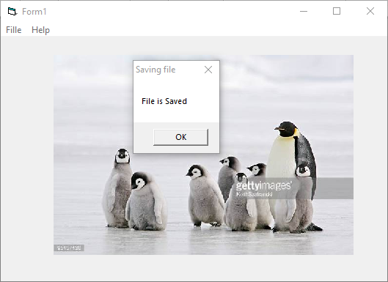

**Pic1:** After Clicking on Save on File Menu

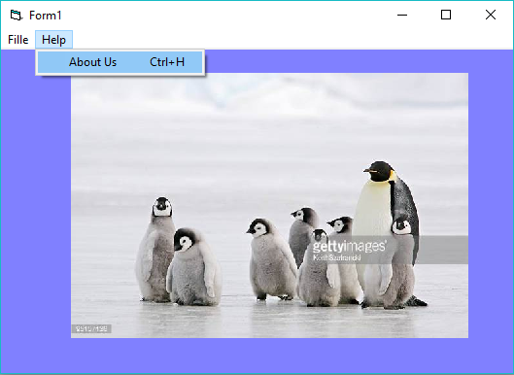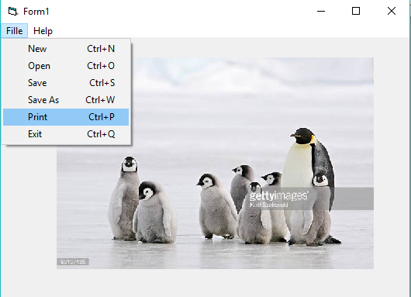**Pic2:** After Clicking on File Menu

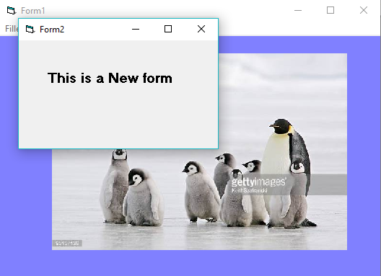**Pic3:** After Clicking on Print from File Menu & Selecting colour

**Pic4:** After Clicking on New from File Menu

**Form Code:**

**For Form-1:**

Private Sub About_Click()

Call MsgBox("This is the week 6, 3rd Assignment")

End Sub

Private Sub Exit_Click()

Unload Me

End Sub

Private Sub New_Click()

Form2.Show

End Sub

Private Sub Open_Click()

cd1.Filter = "Image Files | *.jpg;*.jpeg;*.bmp;*.gif;*.png"

cd1.ShowOpen

Image1.Picture = LoadPicture(cd1.FileName)

End Sub

Private Sub Print_Click()

cd1.ShowColor

Form1.BackColor = cd1.Color

End Sub

Private Sub Save_Click()

Call MsgBox("File is Saved", vbOKOnly, "Saving file")

End Sub

Private Sub Saveas_Click()

Call MsgBox("Save The File As", vbOKCancel, "Saving file as")

End Sub